1. **What was the date & time your team met?**

13/10/2024 @7pm

1. **What is your team group name?**

NextGen Scholars

1. **What is your team’s agreed-upon problem statement?**

The challenge of low-quality education in Nigeria affects millions of students, particularly in rural areas where access to trained teachers and educational resources is limited. This issue has persisted for decades, contributing to poor learning outcomes, high dropout rates, and a widening gap in the nation's education system. With Nigeria’s growing youth population, the need for an innovative solution to address these disparities is urgent.

The problem is most prevalent in rural communities, where inadequate infrastructure, insufficient learning materials, and underqualified teachers hinder educational progress. The majority of students in these regions face barriers that prevent them from accessing quality education, contributing to the country's high rates of illiteracy and unemployment. This situation has long-term implications for Nigeria’s socio-economic development, as an undereducated population limits national growth.

Technology presents an effective solution to this problem. By implementing digital learning platforms, mobile education applications, and virtual classrooms, students in underserved areas can gain access to a wealth of knowledge, regardless of their geographic location. These tools also allow teachers to receive ongoing training, improving their teaching skills and enabling them to deliver a higher standard of education.

Through collaboration between the government, private sector, and educational institutions, Nigeria can adopt scalable and affordable technological interventions that bridge the education gap. This approach will ensure that every child, regardless of where they live, has the opportunity to receive a quality education, ultimately driving national progress and reducing inequality.

1. **Share all your team roles,**

Mike Akpe - Project Manager/Project Manager

Emili Celestine Eze - Data Analyst

Adedayo. J. Adebayo - UX/UI

1. **What is the scheduled date and time of your Week 5 team meeting?**

14/10/2024 @5:30pm

1. **Share 2 data visualizations that are relevant to your team’s problem statement and align with the team’s goals and priorities**

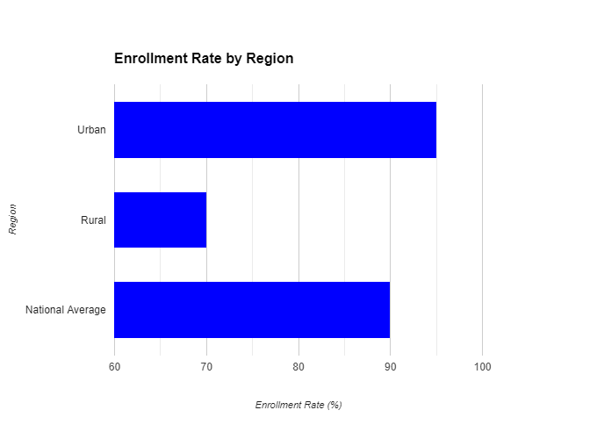

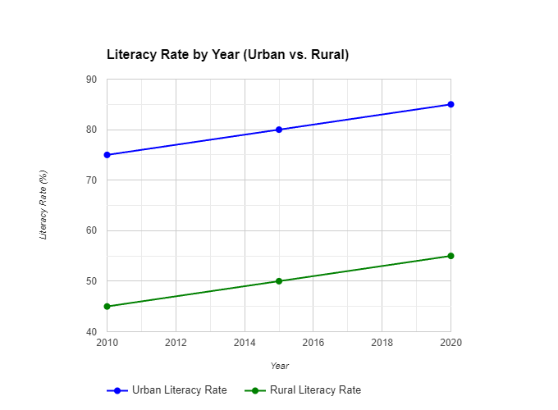

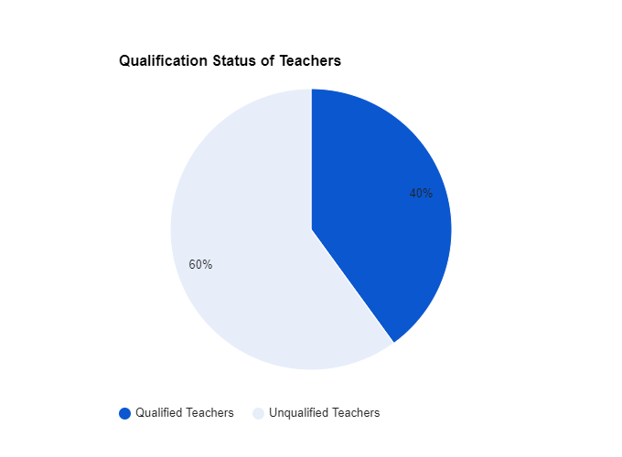

1. What are your action items from the team meeting? (what do you need to do before the next meeting?)

Our action plan centers on designing an app and website tailored to enhance educational access in Nigeria. We will prioritize user-friendly interfaces to ensure accessibility for all, particularly in rural areas. The platform will feature resources tailored to students and training modules for teachers. Collaborative input from educators and stakeholders will shape the design, ensuring it meets the diverse needs of its users effectively.

1. **Provide the data visualizations that you worked on with your team, and in 2 - 3 sentences write your analysis of each visualization.**

The challenges that pupils in remote regions encounter are underscored by the disparity in enrolment rates between metropolitan and rural areas. Although urban areas may have more convenient access to educational facilities and resources, rural communities frequently encounter socio-economic barriers, limited infrastructure, and a scarcity of qualified instructors. It is imperative to invest in rural education, construct new schools, provide transportation options, and implement targeted programs to encourage school enrolment and retention in order to bridge this gap.



Additionally, the literacy rates indicate that there is a necessity for ongoing endeavours to enhance educational outcomes. Although progress has been achieved, there is still place for development, particularly in rural areas. Nigeria can improve its human capital and stimulate economic development by investing in early childhood education, promoting literacy programs, and guaranteeing access to quality education for all.



The substantial proportion of educators who lack qualifications is a significant issue. It implies that a significant number of pupils are not receiving instruction from individuals who possess the requisite qualifications and training. This can result in inadequate curriculum delivery, inferior teaching practices, and restricted opportunities for students to realise their complete potential. A comprehensive approach is necessary to address this issue, which includes enhanced working conditions, competitive compensation, and increased investment in teacher education and training programs.

1. **Write a reflection on your experience and your team’s effectiveness so far.**

Reflecting on our team's effectiveness, I'm pleased with our collaborative spirit and open communication, which foster a positive working environment. During our last meeting, we successfully brainstormed innovative features for our app, showcasing everyone's creativity. However, we could improve by setting clearer agendas to enhance focus. Personally, I’ve felt some frustration with scheduling conflicts; I plan to propose a fixed meeting time for consistency. I would rate my communication ability at 3, as there's always room for improvement. My main concern for Month 2 is ensuring equal participation, and I hope to address this through structured discussions. Overall, I’d rate our teamwork as a 3, as we are progressing well but can refine our processes further.